AV/IT guide for the Verdon-Smith International Seminar Room

Table of Contents
1. Hybrid meetings and seminars 1
2. Room equipment 1
3. Controlling the Equipment 2
3.1 AV Controls 2
3.2 Camera 2
3.3 Audio 3
4. IT Related information 3
4.1 Logging on 3
4.2 Select which device you want to use (PC or LAPTOP) 4
5. Video conferencing 4
6. Finishing your Session 4
7. Fault reporting 4

Hybrid meetings and seminars
- We recommend no more than a maximum of 8 people in the room as there is a certain level of noise distortion due to the limitations of the space and equipment which can affect the sound for those joining virtually.
- In person participants should be seated around the table at the far end of the room in order to provide the best camera view. The camera’s pre-settings (buttons 1 and 2) allow for this set up.
- Position the extendable microphone centrally where participants are seated.
- To optimise the experience for virtual participants we advise that the meeting chair or event organiser invites participants to take turns in speaking to avoid people speaking over each other.

Room equipment

- Dell PC and lectern
- 86” Interactive Display
- Logitech video conference screen with incorporated room camera and audio
- Camera control
- Expansion microphone with extension cable
- HDMI cable for laptop (one cable for audio and video)

3. Controlling the Equipment

3.1 AV Controls
This section of the guide will assist you in getting started. The AV Touch Control Panel on the lectern enables the remote control of the IT and AV equipment from one centralised controller. From the panel you can select which source you wish to display/hear and adjust the volume. | 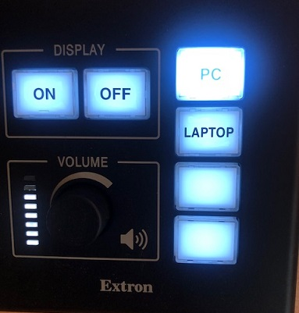

3.2 Camera

The camera is located at the top of the screen.  A green light will indicate that it is switched on and operational. | 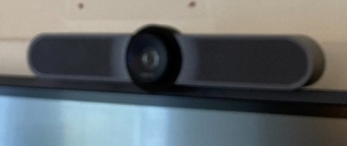

The control panel for the camera will be located on the lectern.  Buttons 1 and 2 at the bottom of the control are pre-set, you can use the round button in the middle to adjust these as required. | 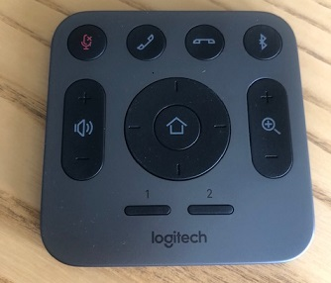

3.3 Audio

Audio is integrated into the screen and there is an extendable microphone.  The table located in the centre of the oval configuration should be used to position the extendable microphone.  The volume can be adjusted from the lectern PC. | 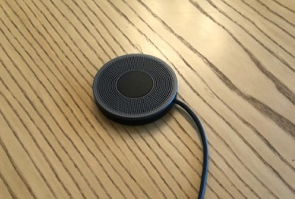

4. IT Related information

4.1 Logging on

Press the ON button on the lectern control panel, it will flash while the system starts up, and will remain solid when the system is ready. During this time, you will be unable to press any other button. Once the ON button stops flashing a device can be selected.
NB. if the PC does not start you may need to press and hold the button on the panel inside the lectern cupboard (highlighted in yellow below), you may need to do this a couple of times to wake the computer up, it will switch off if it hasn't been used for a period of time.

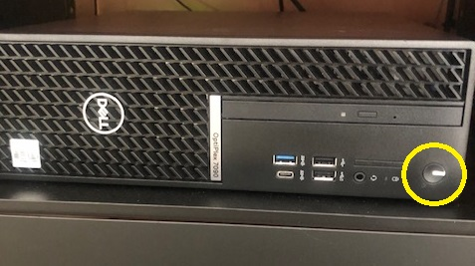

4.2 Select which device you want to use (PC or LAPTOP)
If using the PC, log on with your UoB log-in information. Press the relevant device button which will light up. There may be a 3-5 second delay when switching devices.
If you are using a laptop connect to the HDMI cable provided.
You will need a display adaptor if you are using an Apple laptop.

5. Video conferencing

The camera and audio are linked to the in-room PC and can be used with the video conferencing software (e.g. Teams or Zoom).

Remote attendees cannot see projected content. If you wish to also share content (e.g. slides or a padlet) you must also “screen share” to the meeting from the device you are using.

6. Finishing your Session

Before leaving the room, press the POWER ON/OFF button, unless you can see the next member of staff waiting to use the room.
Finally, please ensure the room is left ready for the next user by:
- Logging-off from the PC. (Do NOT shut down the PC).
  - Do NOT remove any cables from existing sockets connected to the PC
- Leave the camera control and AV guide on the lectern.
- Ensure you have complied to all of the requirements in the ‘Booking Policy’ document, including returning furniture to its original location and clearing away any catering, rubbish or other debris from your meeting. Please do NOT leave any catering to be collected outside of the room in the corridor.

7. Fault reporting

If you encounter difficulties with logging on or any of the equipment, please contact IT Services as follows:
IT self-service Site: https://www.bristol.ac.uk/it-support
Phone: 0117 42 82222 (Mon-Fri, 08:00-17:15)
In addition to reporting the issue to IT Services we would be grateful if you could also notify ird-office@bristol.ac.uk.

